Name:_________________________________
CIFSC “Connection”
T-Shirt Order Form
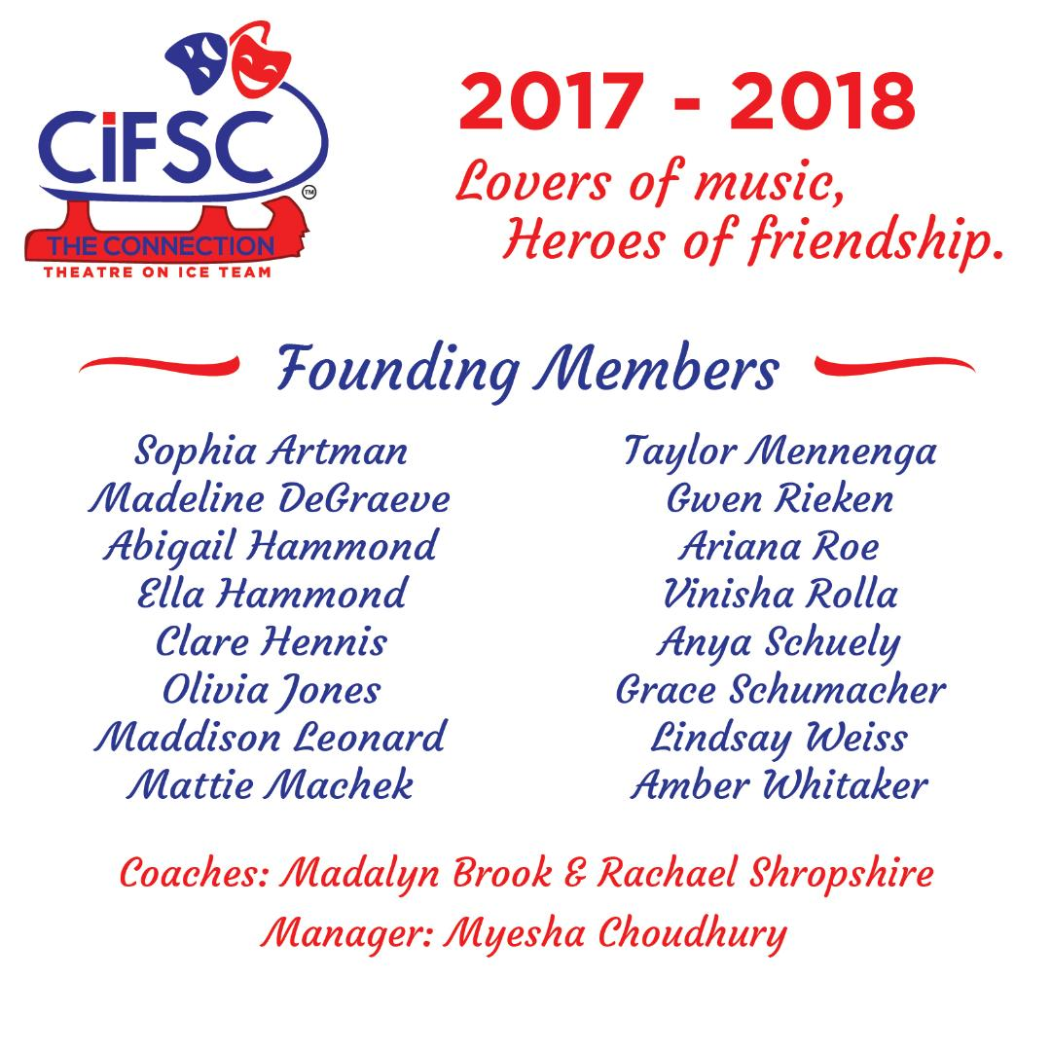
Baseball style T-shirts will be ¾ sleeve length, sleeves will be black and shirt will be white. Connection Logo will be on the front with names of all team members on the back of the shirt.
ORDER DEADLINE IS 6/10!
Adult Sizes - $17
Small___ Medium___ Large___ X-Large___ XX-Large___ (add $2) XXX-Large___ (add $4)

Child Sizes - $17
Small___ Medium___ Large___
(Please indicate number of each size if more than one)

Total Paid $_________ cash or check (made payable to CIFSC) accepted
Paid Cash___ Paid Check___
**Please turn in orders with payment to team manager, Myesha Choudhury. If you are unable to turn in your form by 6/10 please email your order to Myesha @ ska8rmkc@comcast.net**

