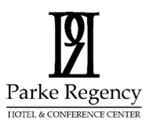

Parke Regency Hotel & Conference Center
1413 Leslie Dr., Bloomington, IL. 61704; Tel 309.662.4300; www.ParkeRegency.com

The newly renovated 70 room BW Premier Collection, Parke Regency Hotel & Conference Center has opened its doors. The million-dollar renovation included the complete transformation of its lobby which now has a workstation and large family area for gathering. A state-of-the-art fitness center, pool area, slot machines/sundry shop and guest laundry. Every guestroom has been designed with the guest's comfort as the main focus. You will never run out of places to charge your technology and stay connected.
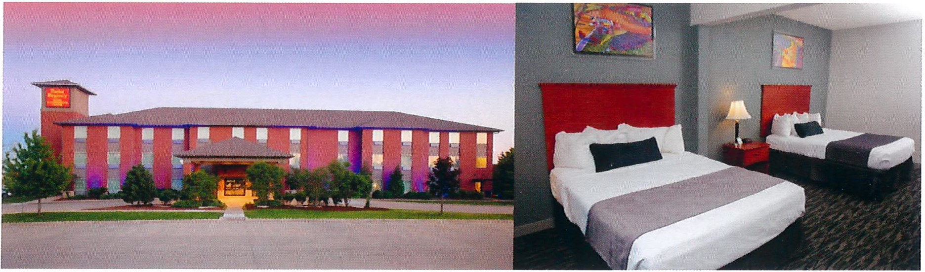
Guests will enjoy the following amenities:
- High speed & wireless internet in all Guest rooms and public areas.
- 50-inch Flat Screen Tvs with over 70 HD channels
- Mini Refrigerators/Microwaves, and Coffee makers in all rooms
- Complimentary Hot Breakfast from 6:30 am to 9:30 am
- Slot Machines & Sundry Shop
- Deluxe Fitness Room
- Bon Chon Korean Restaurant opened Friday and Saturday 11a to 10p and Sun-Thursday 11a-9p
- Brand New Serta Deluxe Hospitality Mattresses in all the rooms on December 2023
- We are also part of the Clean and Safe Protocol Cleaning Program
- Outdoor Swimming Pool is currently closed

Central IL Excell & Beyond
May 17-19, 2024
$105.00 plus room and taxes per night (regular rate $169.00 a night)
For Standard King or Standard Room with 2 Queen Beds
Reservations must be made by April 24, 2024 to be guaranteed this discounted rate
We are expecting to sell out this weekend- please make sure you secure room by the cut off date
Cancellations or changes must be done by 4 pm on May 10, 2024
You can call the hotel directly at 309-662-4300 ext 5

